FINAL Project – Proposal

Online Interactive Portfolio

Ariane Hipsagh – 22689812

CART 351 – Networks & Navigation – Autumn 2018

GitHub at <https://github.com/Ahipsagh/CART351/tree/master/Project/FINAL/Proposal>

Professor Sabine Rosenberg

November 5, 2018

# Project Description

The FINAL project proposal is to create an Interactive Online Portfolio (IOP) to create an interactive social media online presence to showcase a gallery of art works. A portfolio is the calling card of today’s computation artist. I look forward to participating in the vibrant Montreal Gaming and Video market and am convinced that an online portfolio using as many web tools and techniques will open the way to that goal. The IOP is by design malleable and can morph to suit the needs of the industry. The project is divided into four phases. The goal is to easily maintain an online portfolio that can change to meet current trends. It uses a database that is populated by the owner over time. The owner can decide which items to feature by making them active. The gallery is organized into categories and offers a search option. The portfolio is further augmented by offering interactivity with social media platforms by encouraging likes and shares. Eventually, based on likes, shares, and industry trends an algorithm can determine the top art works to display to the audience.

Technologies used for the FINAL Project include HTML, CSS, Javascript, AJAX, JQuery, PHP, SQLLite, API’s for social media platforms such as YouTube, FaceBook, Twitter, Instagram, and more.

## Phase 1

IOP that permits the owner to update the gallery by adding, deleting, modifying the current portfolio. Basic links to social media platforms as well as contact details are included.

## Phase 2

Add functionality to modify gallery by moving components around with drag and drop. Organize with help of categories.

## Phase 3

Add a social media interactivity by way of search, share and like to IOP

## Phase 4

IOP opens with top favourites displayed. Add trailer video à la YouTube.com.

# Storyboard

|  |  |
| --- | --- |
| 1. Interactive Online Portfolio | 2. Social Media Icons |
|  |  |
| Source: https://themeforest.net/item/massive-dynamic-wordpress-website-builder/13739153?ref=Datasata | Source: https://social-media-strategy-template.blogspot.com/2013/01/building-blocks-social-media-strategy.html |
|  |  |
| 3. Like, Share and contact | 4. Categories, filters |
|  |  |
| Source: https://www.iconfinder.com/icons/724251/accept_favourites_feedback_like_social_success_thumbs_up_icon#size=128 | Source: https://dribbble.com/shots/2455000-Scandid-Filters/attachments/478587 |
|  |  |
| 5. Search database | 6. Video Trailer |
|  |  |
| Source: https://i.pinimg.com/originals/37/a5/58/37a558b32ca62a9b2a16094533952dd3.jpg | Source: https://www.youtube.com/channel/UCYkLJ-ZiwHSKcR0kKfznKmA |

# Research of 3 similar projects

## Il-Ho-Jung

Minimalist design with classic gallery. This portfolio is easy to navigate. Interactive components a visually interesting. It is not obvious how to contact the artist.

<http://il-ho.com/#/news/3>

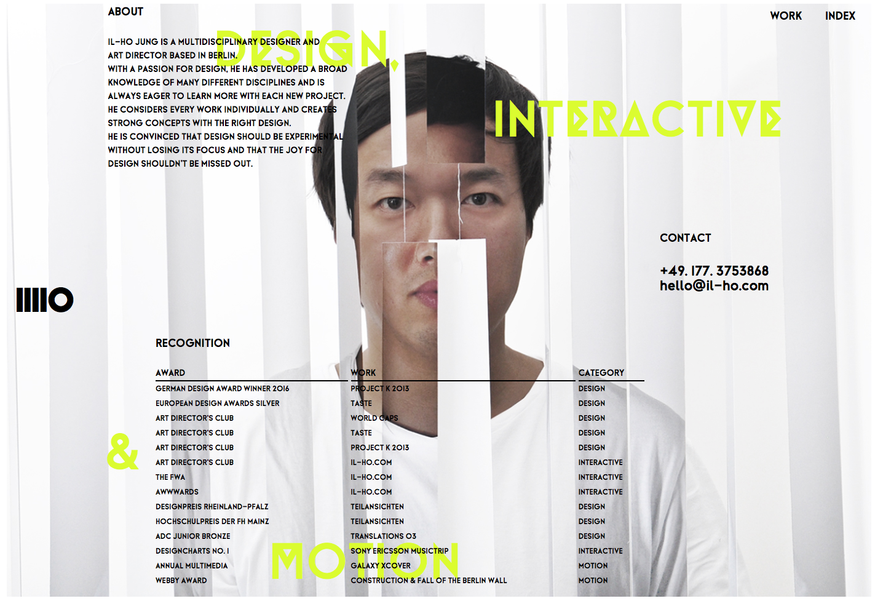



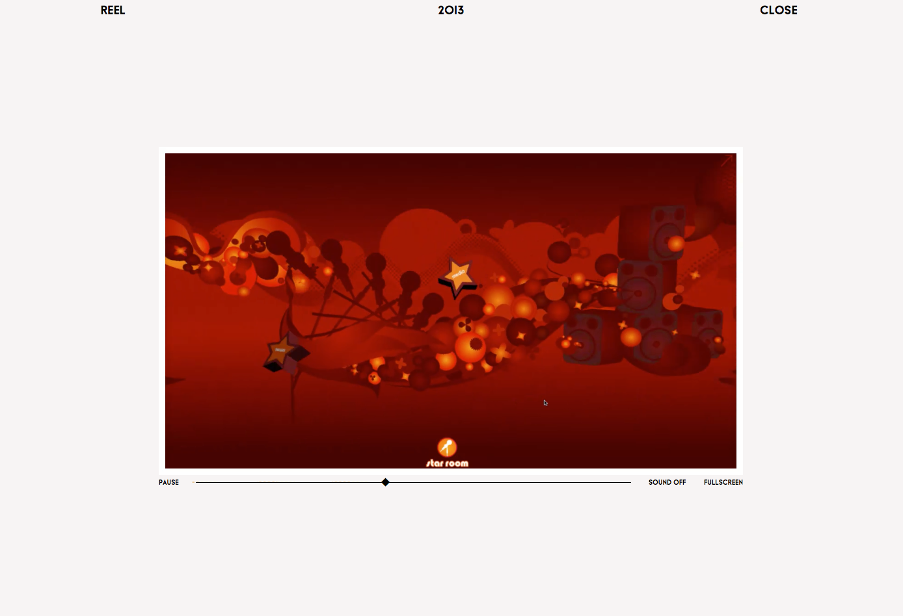

## Aaron Meyers

Clean minimalist design. The site is constantly moving and visually stimulating. The artist has a strong branding. Navigation is effective.

<http://aaron-meyers.com/!/>

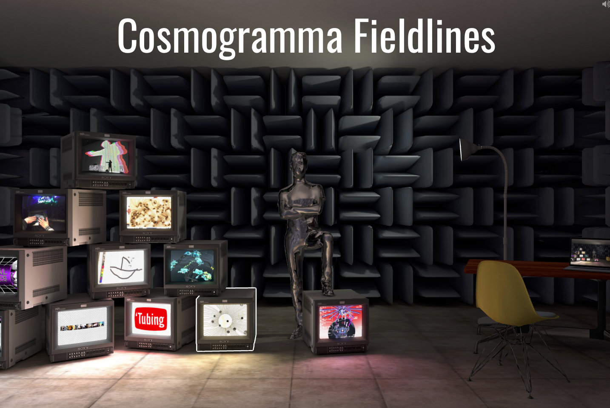

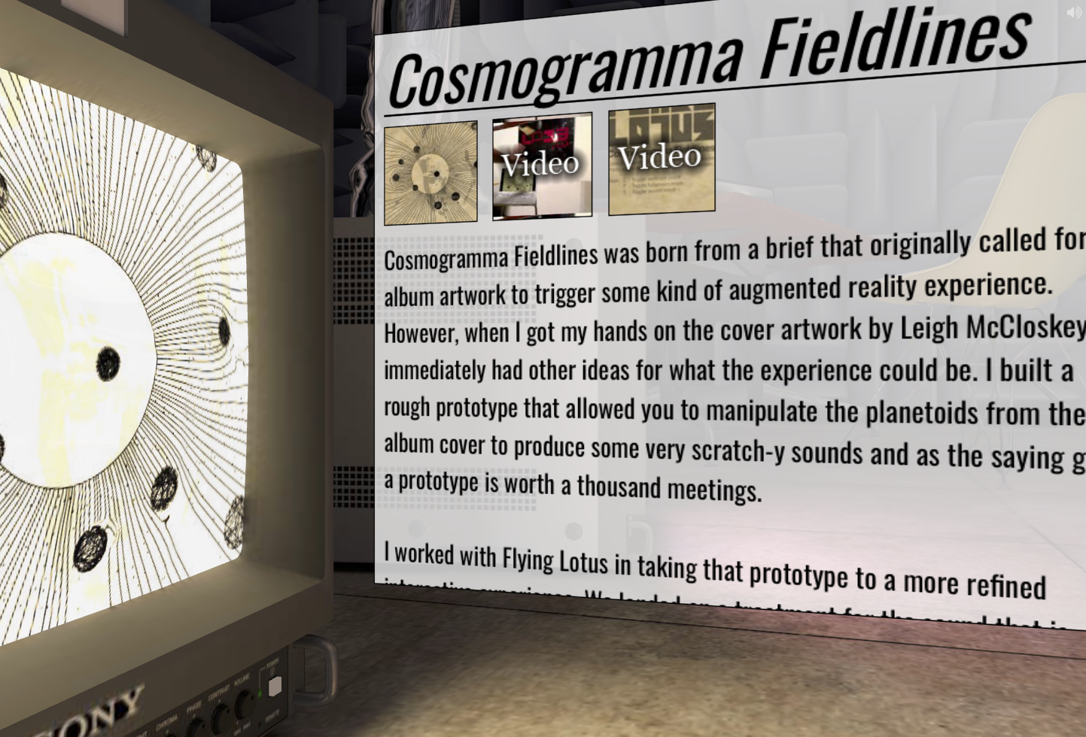

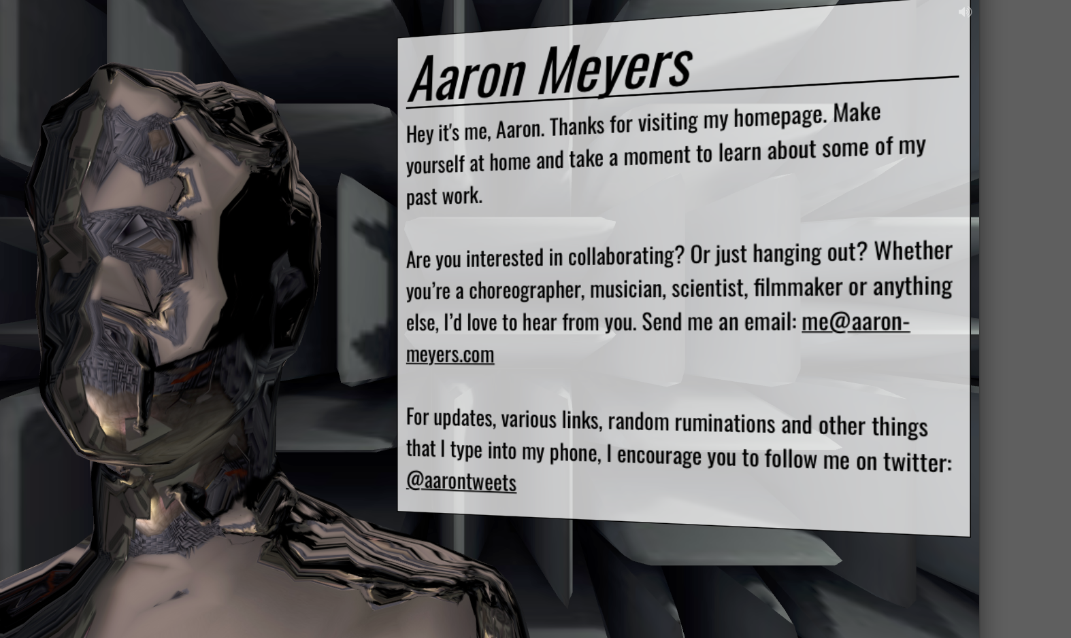

Unusual navigation and interactivity. Using animation immediately on home page. The site is conceived to be the 3d personality, Aaron Meyers. The audience can move around the environment.

## Nahel Moussi

[http://www.nahelmoussi.com/#tesla](http://www.nahelmoussi.com/" \l "tesla)

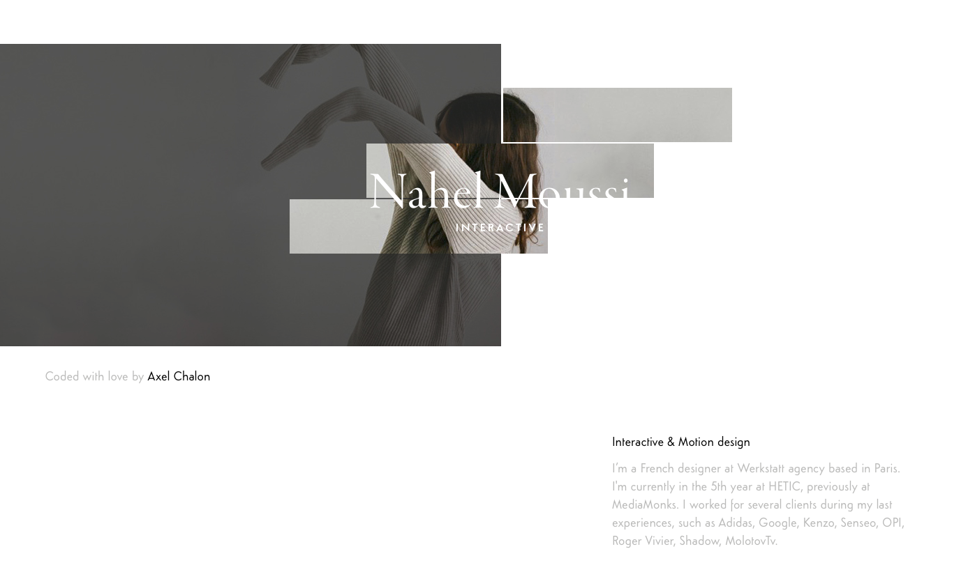

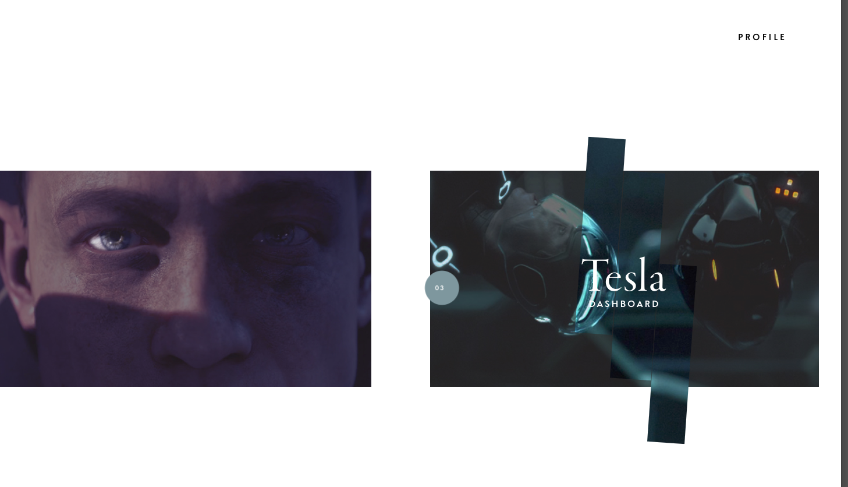

# Different ?

The IOP differs from the three researched online portfolios in that it is set up to be easily updated by the owner. This way the owner can toggle on and off the works to be featured in the gallery. The goal is to eventually engage the social media community in a one to many, many to one and many to many conversation. This ongoing work in progress hopes to create an algorithm to combine the likes, shares, and search criteria to automatically determine the top artworks to feature.